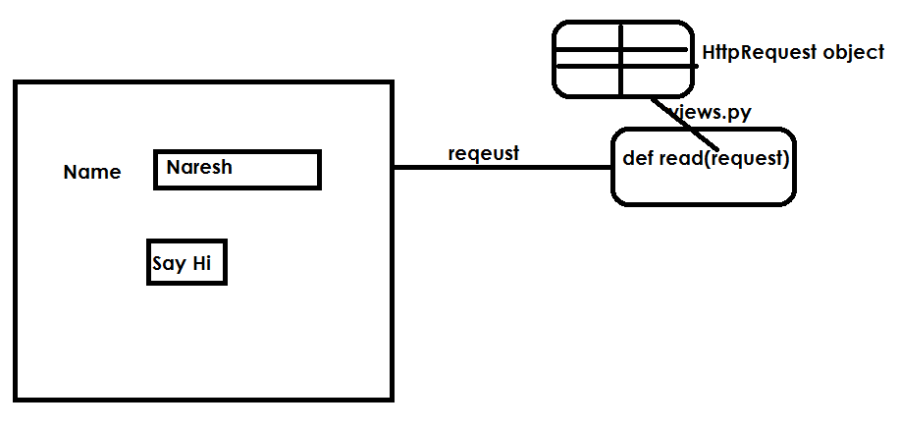

1. create project

django-admin startproject requestproject1

1. create application within project

python manage.py startapp app1

1. create templates folder within project
2. inside templates folder create home.html

<html>

<body>

<form action="/v1">

   Name <input type="text" name="t1"><br>

   <input type="submit" value="say hi">

</form>

</body>

</html>

1. views.py

from django.shortcuts import render

from django.http import HttpResponse

# Create your views here.

def home(request):

    r=render(request,"home.html")

    return r

def view1(request):

    n=request.GET['t1']

    msg="<h1> Hello "+n+"</h1>"

    r=HttpResponse(msg)

    return r

1. urls.py

from django.contrib import admin

from django.urls import path

from app1 import views

urlpatterns = [

    path('admin/', admin.site.urls),

    path('v1/',views.view1),

    path('home/',views.home),

]

1. settings py

INSTALLED_APPS = [

    'django.contrib.admin',

    'django.contrib.auth',

    'django.contrib.contenttypes',

    'django.contrib.sessions',

    'django.contrib.messages',

    'django.contrib.staticfiles',

    'app1',

]

TEMPLATE_DIR=os.path.join(BASE_DIR,"templates")

TEMPLATES = [

    {

        'BACKEND': 'django.template.backends.django.DjangoTemplates',

        'DIRS': [TEMPLATE_DIR],

        'APP_DIRS': True,

**What is a URL dispatcher?**

URL dispatch **provides a simple way to map URLs to view code using a simple pattern matching language**. An ordered set of patterns is checked one by one. If one of the patterns matches the path information associated with a request, a particular view callable is invoked.

**HTTP Request methods**

Request is information send by client server/view

Request is input given by client to server/view

Client can send request using various request methods

1. GET
2. POST

GET request is used to read information from server

GET request does not perform any changes at server side

In GET method, the data send to server by concatenating with URL

The data is visible in URL, so we cannot send secured data

We cannot send large amount of data because of URL length restriction. This length changes from browser to browser.

We can send data as a plain text

HTTP request object consist of,

1. Request URL
2. Request parameters/data
3. Request header

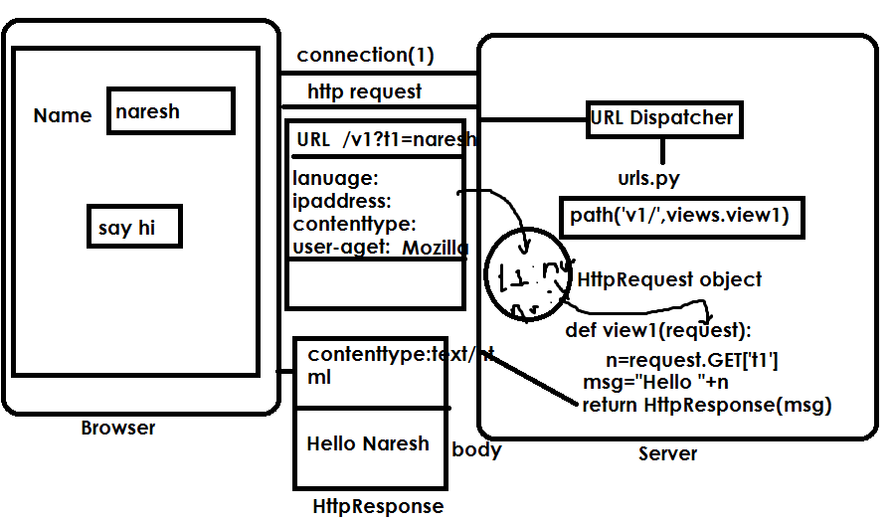

**Application:**

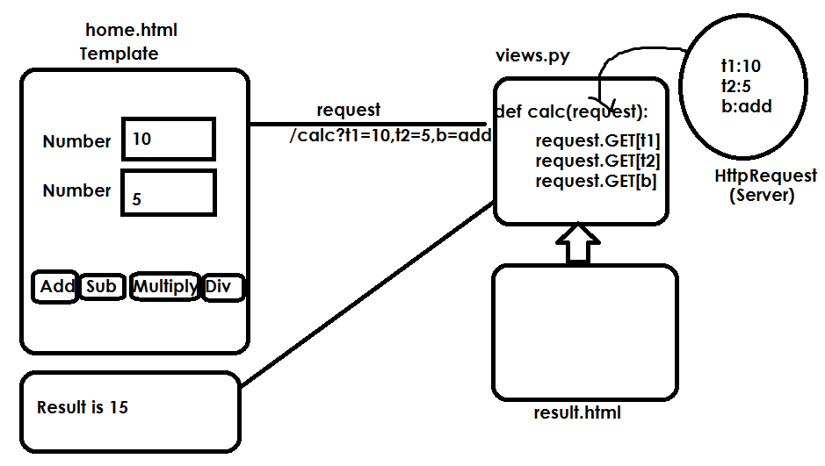

1. Create project

django-admin startproject requestproject2

1. Create application

python manage.py startapp app1

1. Create templates folder within project
2. Inside templates folder create

**home.html**

<html>

<head>

<style>

    div{

        width:fit-content;

        height: fit-content;

        margin-left: 100px;

        margin-top: 50px;

        border-style: double;

        border-width: 5px;

        background-color: azure;

    }

</style>

</head>

<body>

    <div>

        <form action="/calc" method="GET">

            Number <input type="text" name="t1"><br>

            Number <input type="text" name="t2"><br>

            <input type="submit" value="add" name="b">

            <input type="submit" value="sub" name="b">

            <input type="submit" value="mul" name="b">

            <input type="submit" value="div" name="b">

        </form>

    </div>

</body>

</html>

result.html

<html>

<body>

    <h1> Result is {{res}} </h1>

</body>

</html>

1. **Views.py**

from django.shortcuts import render

from django.http import HttpResponse

def home(request):

    res=render(request,"home.html")

    return res

def calculate(request):

    n1=int(request.GET["t1"])

    n2=int(request.GET["t2"])

    b=request.GET["b"]

    if b=="add":

        res=n1+n2

    elif b=="sub":

        res=n1-n2

    elif b=="mul":

        res=n1*n2

    elif b=="div":

        res=n1/n2

    res=render(request,"result.html",context={"res":res})

    return res

1. **settings.py**

INSTALLED_APPS = [

    'django.contrib.admin',

    'django.contrib.auth',

    'django.contrib.contenttypes',

    'django.contrib.sessions',

    'django.contrib.messages',

    'django.contrib.staticfiles',

    'app1',

]

TEMPLATES_DIR=os.path.join(BASE_DIR,"templates")

TEMPLATES = [

    {

        'BACKEND': 'django.template.backends.django.DjangoTemplates',

        'DIRS': [TEMPLATES_DIR],

        'APP_DIRS': True,

1. **urls.py**

from django.contrib import admin

from django.urls import path

from app1 import views

urlpatterns = [

    path('admin/', admin.site.urls),

    path('home/',views.home),

    path('calc/',views.calculate),

]

**Request method POST**

In request method POST data is send as part of request body

Data is not visible on URL

We can send secured data

It allows sending large amount of data

POST is a request used for writing data to server

Example: inserting , update, delete